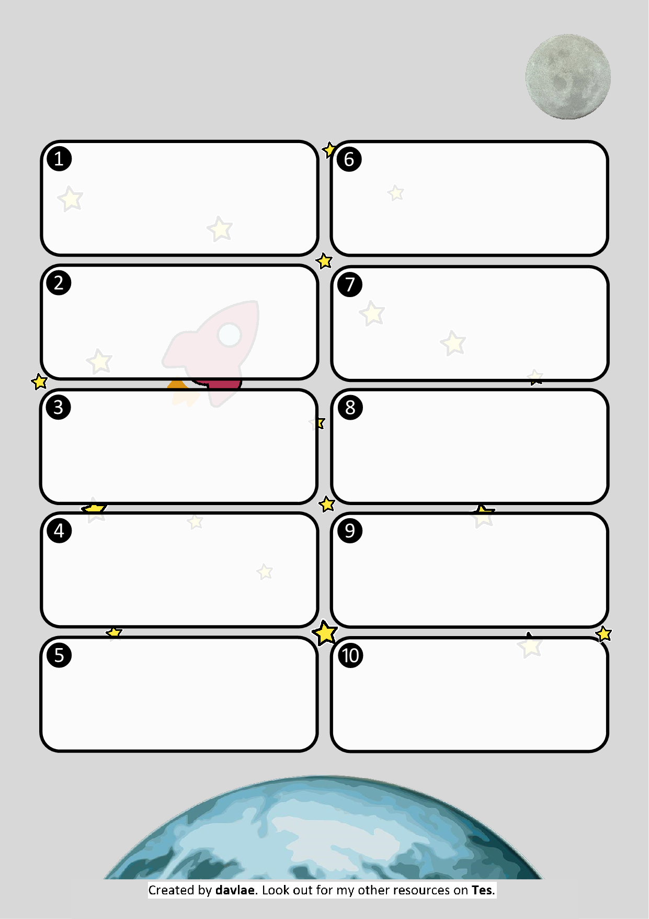

**Delete what is written in each box and save as a blank master copy.**

**Create your own literacy or mathematics worksheets.**

**Could be used to create your own morning work or extension activities.**

**Suggest other backgrounds via Facebook or using the contact form on my website.**

**You can even change the title at the top of the page!**

**Keep an eye on** [**www.davlae.co.uk**](http://www.davlae.co.uk) **to see what new resources I have added.**

**You can type questions straight into any of the boxes.**

**Reach for the Stars**